Optimizing the Sort

- Maven comes with a built-in repository manager client.
- You specify the dependencies in maven using artifact
- artifacts are defined by artifactID, groupID and Version
- repository can only have one artifact, if the version number ended with -SNAPSHOT then this uniqueness is not required or guaranteed.
- There is a local repository on local machines in ~/.m2/repository where artifact is stored
- to specify a dependency in maven:
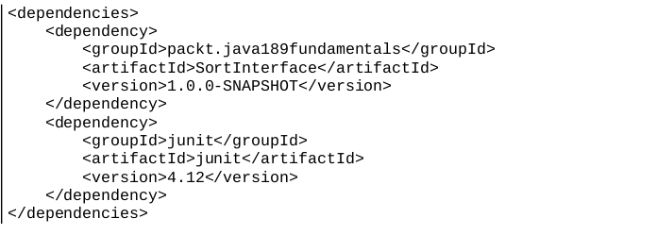
- if the project is multi-modlue then you can specify the version in the project main POM and then you don’t specify it in separate modules, that way if you want to change the version you change it only from one place.

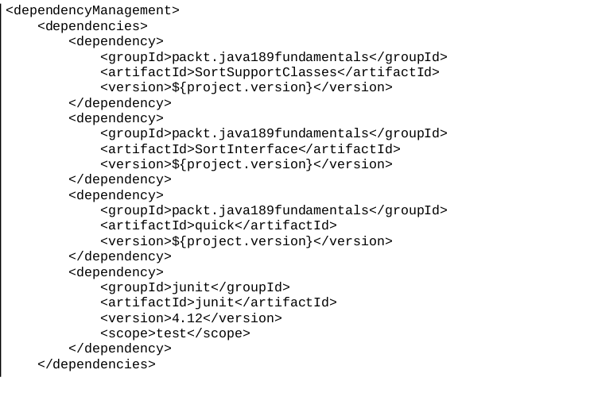
- Test Levels:
- Unit tests: test a unit of code
- Integration tests: test how the units integrate together
- Smoke tests: test a limited set of features just to see that the code is not totally broken.
- There are other tests until we reach the final test and user acceptance test.
- When you set the scope of a dependency to be test this means that this dependency will not be in production code.
- To run the tests with maven => mvn test
- the Junit framework will call every method that has the @Test before it
- you must in the testing method assert the output, Assert.assertEqual(…,…)
- Good Unit tests should be:
  - Readable: canSortEmptyList(), canSortOneElementList() …
  - Fast
  - Deterministic: if a unit test fails it should fails no matter how many times it is run.
  - Isolated: a unit test only tests one unit of code, if different unit code got broken our unit test should run fine and not affected by other units of code.
  - Cover the code: during running the test all lines of code should be executed.

